;

**COMP 4320**

**Introduction to Computer Networks**

Project #: Lab 2

Logan Bolton

10/6/2025

# Executive Summary

Format:

* Font: Arial
* Font Size: 11
* Spacing: Double

This section should begin on a new page. The executive summary should include a summary of the findings and decisions

# Table of Contents

Table of Contents

Executive Summary 2

Table of Contents 3

1 Part 1 – TCP 4

1.1 Beginning Questions 4

1.2 TCP Basics 5

1.2 TCP congestion control in action 8

2 Part 2 - UDP 9

1. There are four fields: 4 fields: Source Port, Destination Port, Length and Checksum. 9

12](#_Toc210603025)

3 Part 3 - IPv4 vs IPv6 Traceroute 12

2. IPv4 took 27 hops and IPv6 took 22 hops. The IPv4 path is 5 hops longer than the IPv6 path. 14

4 Acknowledgements 16

5 References 17

6 AI Use Reflation Statement 17

# 1 Part 1 – TCP

## 1.1 Beginning Questions

1. My IP address is 172.17.48.138 and my port number is 64701.

2. The server IP address is 217.21.95.185. It’s port number is 80.

## 1.2 TCP Basics

1. The segment that initiates the connection has a relative sequence number of 0. It can be identified by how it says [SYN] and Seq=0 in the info.

2. The sequence number of the reply is 0. The value of the acknowledgement field is 1. Since the seq value was 0, the ack value was +1, resulting in the value 1. [SYN, ACK] in the info identifies it as a SYNACK segment.A screenshot of a computer screen

3. The sequence number of the segment containing the POST command was 149055.

4.

|  |  |  |  |  |  |
| --- | --- | --- | --- | --- | --- |
| Segment | Seq | Time | RTT | Ack Time | EstimatedRTT |
| 403 | 1 | 6.425416 | 0.288396000 | 6.137020 | 0.288396000 |
| 404 | 1 | 6.425418 | 0.288295000 | 6.137123 | 0.288383375 |
| 405 | 1 | 6.428940 | 0.291726000 | 6.137214 | 0.288801203 |
| 406 | 1 | 6.428941 | 0.291700000 | 6.137241 | 0.289163553 |
| 407 | 1 | 6.431449 | 0.293985000 | 6.137464 | 0.289766234 |
| 408 | 1 | 6.431451 | 0.293965000 | 6.137486 | 0.290291079 |

5. The length is 0

6. The minimum window size was 743 with a calculated window size of 95104. There was never any throttling.

7. Yes, there was one retransmission. It says it in the info section



8. In the ACK for one request, the window size was about 2054. I did not find instances of skipping.

9. The first data segment sent was 6.137516s and the last ACK that confirms the final byte was 6.431453s. 6.431453 − 6.137516 = 0.293937 s. The total amount of bytes in the POST was 149,393 bytes.  
149,393 bytes / 0.293937 s = 508,248 B/s.

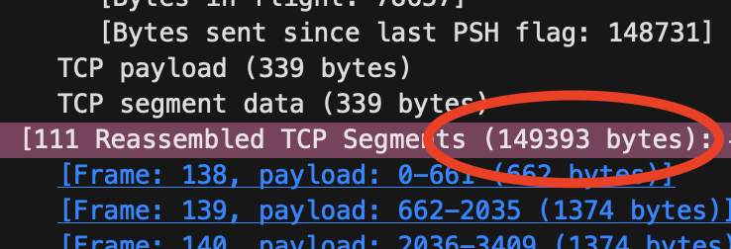

## 1.2 TCP congestion control in action

1. The low start is visible from about 0.28 s through 1.34 s. The upload completes before any transition to congestion avoidance. Unlike the ideal model, it starts with a larger initial window and shows irregular growth.

# 2 Part 2 - UDP

### 1. There are four fields: 4 fields: Source Port, Destination Port, Length and Checksum.

2. Each UDP header field is 2 bytes. The total header size is 8 bytes

3. It is the size of the headers (8 bytes) and the size of the data (4 bytes). The 8 + 4 = Length 12.

4. The max IPv4 size is 65,535 bytes. The IPV4 header is 20 bytes. The UDP header is 8 bytes.

5. The largest possible value is 65,535.

6. UDP’s IP protocol number is 17 (decimal) = 0x11 (hex)

7. The source and destination ports flip values between the packets

# 3 Part 3 - IPv4 vs IPv6 Traceroute

1. I used the commands “sudo traceroute -P icmp google.com” for IPv4 and “sudo traceroute6 -I www.google.com” for IPv6. The commands listed in the lab manual did not work for me, but I found equivalent commands for my MacBook. They both output ICMP echo probes.

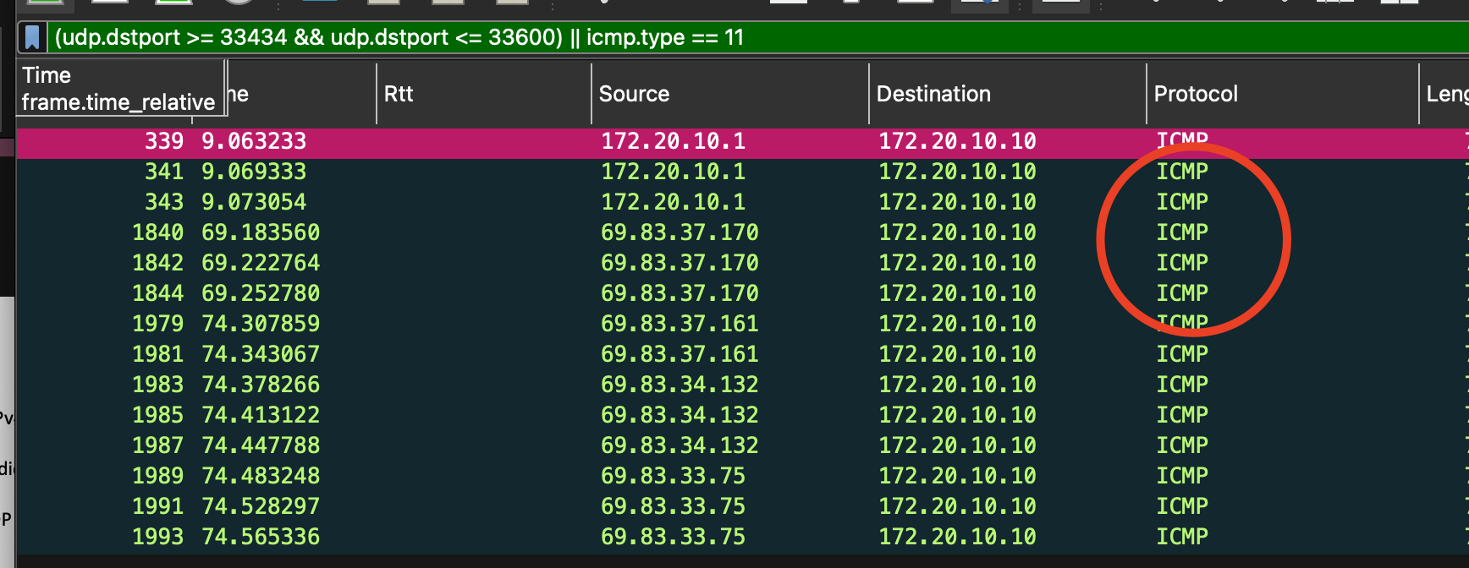

# 2. IPv4 took 27 hops and IPv6 took 22 hops. The IPv4 path is 5 hops longer than the IPv6 path.

3. For hop 14, IPv6 ≈ 61.07 ms vs IPv4 ≈ 41.53 ms and for hop 12, IPv6 ≈ 57.88 ms vs IPv4 ≈ 40.36 ms. One possible reason for the difference is due to different routing domains on v6. The v6 path shows AT&T/Google v6 prefixes, while v4 went through Verizon/AlterNet before Google.

4. For IPv4, the TTL is 1 and the other values are 0x00 → DSCP: CS0, ECN: Not-ECT. For IPv6, the Flow Label is 0x70000, the Traffic Class is 0x00 (DSCP CS0, ECN Not-ECT). Both things prevent packets from looping endlessly in the network by limiting how many hops they can take.

5. The * entries means that one or more routers did not send a response. One reason for this is because of ICMPv6 Time Exceeded errors.

6. IPv4 run ended at mh-in-f138.1e100.net. IPv6 run ended at mg-in-f99.1e100.net (2607:f8b0:4024:c09::63). The different hostnames indicates that they are probably different anycast locations. The different RTTs are fairly similar.

# 4 Acknowledgements

This section allows authors to acknowledge contributors and other sources that are not appropriate to list in the references section.

# 5 References

This is the last section of the report, prior to any appendices. The references should not be double-spaced, but single-spaced. For a technical report, use the CSE style.

[1] Reference 1 information.

[2] Reference 2 information.

[3] Reference 3 information.

# 6 AI Use Reflation Statement

As part of this assignment, you are required to explain how Artificial Intelligence (AI) tools were used in your work. For this you need to describe:

* Purpose of Use – Why you chose to use AI (for example: brainstorming, outlining, checking grammar, simplifying complex ideas, or generating examples).
* Extent of Use – To what degree AI contributed (for example: “I used AI to help refine my outline, but the analysis and arguments were entirely my own”).
* My Contribution – How I ensured the final assignment represents my own original thinking, understanding, and interpretation.

Reflections – What I found useful, what limitations I noticed, and how AI influenced my learning process.

**By writing this reflection, I acknowledge that AI is a support tool, not a substitute for my own effort, and I take full responsibility for the final submission.**